FEP/GNEG Group Coaching
Fall Group Coaching 45 Minute Meeting
08/14/2023 - 09/01/2023 (Date)

Purpose: The purpose of group coaching is for FEP students to connect with their peers, get to know the academic coaches, and reflect on the transition from high school to college. We will be evaluating their systems from high school to see what needs to be changed or kept for college.
Learning Outcome & Assessment: At the end of the group, students will develop an understanding of their system, who the coaches are, and develop networking skills by connecting with their peers.
Packing List:
- The Basics (Outline, pens, etc.)
- Nametags
- Pair-share/systems check handouts (2 half-sheets)
- Notecards
- QR code sign-out sheets
Housekeeping: Set up the room prior for the session.
Group Coaching Basic Flow
- Meet and greet
- Introductions
- Evaluating High School System
- Set outcomes and goals
- Resources
First Week and a Half
Meet and Greet
Introductions and Group Activity (5 minutes)
  - As they’re walking in, have students introduce each other.
    - You can do a get to know you activity/game
  - Hand out nametags (name and major, or “?” if undecided)
Welcome and Overview (3 minutes)
  - Who we are (introduce yourself, role, coaching vs. counseling vs. advising vs. peer mentoring, gratitude for them being there)
  - Overview: Our aim today is to introduce you all to academic coaching, to each other, and prepare for this transition from high school to college.
  - Agenda: We will start with some get to know each other games, then do an activity where we evaluate what you did in high school to see how it can translate to college. While you are all distinct individuals, you share a huge experience right now---the transition from high school (or gap year(s)) to college.
  - Briefly review ground rules and confidentiality
    - Agree to these ground rules? Thumbs up if so.
  - Optional: breathing exercise (depending on what you need)
Pair share (5 minutes)- break into groups of 2 or 3 unless group size is <6 then keep together
  - Names, hometowns, etc.
  - What makes you interested in engineering?
  - What’s something you could talk about forever?
  - Have each student either share for themselves, or have one person from each group introduce themselves and their neighbor.
Activity: Similarities (5 minutes)
- The point of this activity is to give students questions they can ask anyone, and realize how much they have in common with the people in the room.
  - Have everyone get in groups based on:
  - Cats/dogs/neither?
  - What is your birthday month?
  - What food do you like?
  - Which dorm do you live in?
  - Lastly, link up with someone in the room and find the most random thing you have in common, most random thing wins.
Explaining coaching process and structure
- In coaching we often start our meetings getting to know each other, understanding what you care about, and seeing who you want to become over these years.
Systems Introduction (7 minutes)
- What: “Now we are going to do an exercise to check your system from high school to get an accurate read of what you have going on coming into college.
  - What is a system- “Interconnected or related parts working together for a
common purpose (goal)” it is an industrial engineering way of thinking to see if the inputs result in the outputs I want.
  - For example, if you are putting lemons in a juicer, you would expect lemon juice to come out, or if you sowed an apple seed, you would expect to get an apple tree, right?
  - Well, this concept applies to college. If we give time, energy and effort to your classes, we should get a good grade, right? Well, what happens if you think you are putting the time, energy and effort expected but do not get the grades you want? That is when a system check is necessary.
- The goal of today is to build out the components of your system, both academic and personally to start the semester aware of your inputs and outputs. We will do this by walking through a series of questions for you to reflect on. There is no “right” answer for the activity or the questions. You will need to tap into your creativity, imagination, and critical thinking. Try not to judge what comes up for you.
Systems Activity (15 minutes)
Intro to Systems: What you hear the word “system,” what comes to mind? Every system has an input and an output. In academics, our outputs are grades and how well we understood what was being taught. Let’s say we want an A on a test. Everything we do to prepare for that A is your input.
- Outcomes/outputs/goals
  - Semester Commitments
  - Outside of academics- what do you hope to get out of the Fall?
- Input Portion: Explain the systems inputs and outputs with handouts on table.
Discussion: Let’s talk about what you would consider examples of your input to get an A on a test? (Have a conversation about what students consider inputs. Student can work in their groups as well)
- Gather as many examples as possible, then display the “Systems Check Handout” image to see how many of their examples fell under “Time, Content, Resources, and Self-Care).

Systems Check (refer to the handout): “In other words, in Engineering, we like to use a systems model for academic success. Systems always have inputs and outputs. The quality and quantity of students’ input will affect their output.”
- “The amount of time you spend on coursework, the degree to which you understand the content, the actions you take to use resources, and how you prioritize self-care to have balanced physical and mental health will determine an output (grades/understanding).”
- “If you do not get the desired outputs, that is okay. This means you must make adjustments to your inputs, and we can help with that.”
- “Engineering is a very demanding major that can be overwhelming for students that do not adjust their expectations. If students keep their system from high school (doing the minimum work for a grade), they will likely conclude with a C, D, or F in challenging courses.”
[Systems Check Handout]
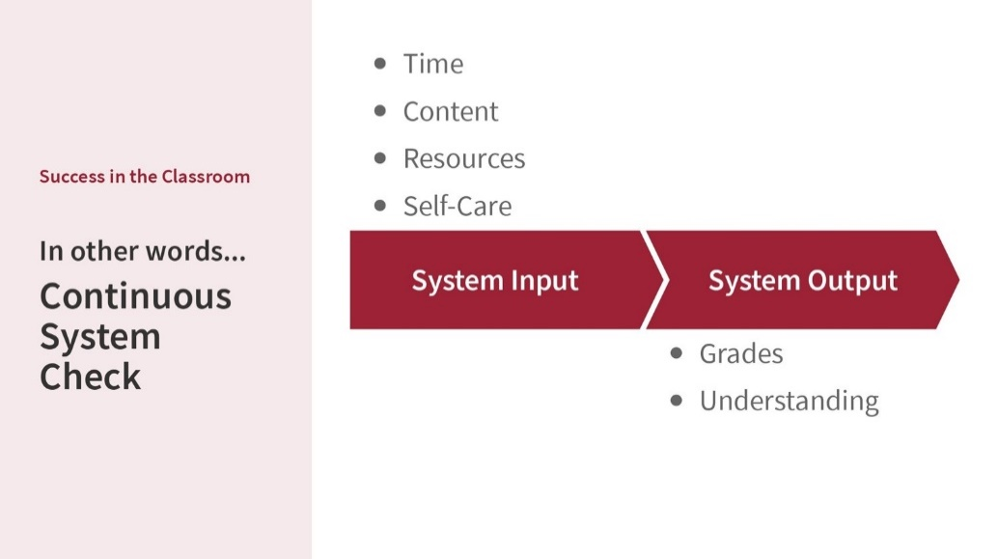

Write on notecard what stood out to you.
  - What outcomes do you hope to get from this semester?
  - What parts of your system do you need to address to achieve these outcomes?

Pair up with 2-3 other people around you and discuss your answers.
- Write anything that you want to remember from what your talked about in your group.
- As a group you are going to decide one person to be your spokesperson to share with the group what stood out.

Concept: live life by design rather than default. Life is spaghetti, not a straight line. Evaluating, implementing, and adjusting your system gives you the ability to design your life rather than it just happening to you. We know there are inputs you cannot control.
Resources and Questions
- Now we are going to take a pivot to discuss resources and any questions you all have as you are stepping into college.
- Write down any resources you have been surprised to learn bout, resources you’re interested in, and/or questions you have. Once all are done, have student share with their groups and discuss as a large group.
- Resources to get you there:
  - Tutoring, office hours, coaching, talking with career services, Student Success, Advisor
How is group coaching different from one-on-one coaching? (2 minutes)
- We will focus on your future- who you want to be- and how to get there. We will listen, ask questions, and offer resources if you want them. Your advisors are there to guide you, we are here to listen to you.
- More efficient with mental energy
What questions do you have? (What are your concerns about this fall?) (10 minutes)
For Engineering Students: Sign out with the QR Code (and give us some feedback- this is your attendance)
- Have QR code on the board with step-by-step instructions of how to fill out the form

